**Project Report**

**Title :** LED Display (based on concept of LED Cube)

**Apparatus :**

* 64 LEDs (16 Red, 16 Yellows, 16 Blue, 8 White, 8 Green)
* Jumper wires (84 - 90 of all types)
* Arduino Nano
* Soldering appliances

**Connections** :

* **LED Connections :**

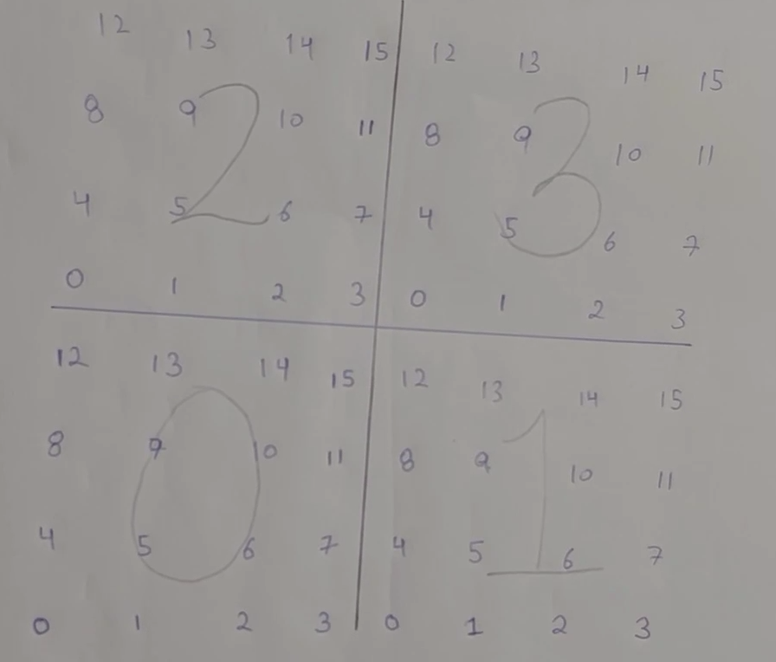

1. The LED display is connected into 4 layers of 16 LEDs each indexed from 0-15.
2. Each layer’s LEDs are interconnected and the index with the same number of all four layers are interconnected.

* **Arduino Connections** :

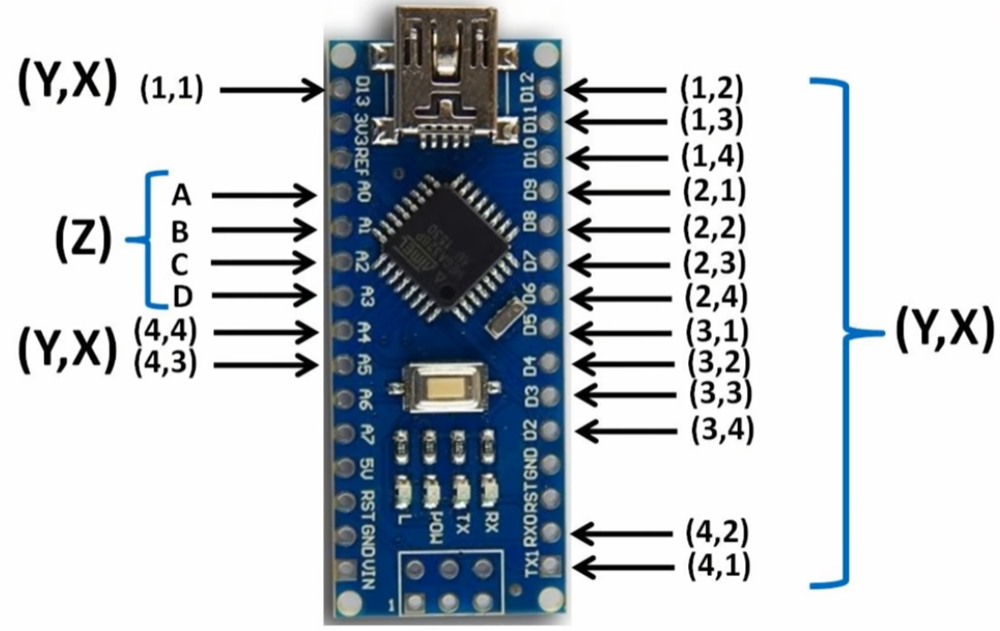

1. We use D2-D13, A4-A5 and TX1-RX0 to connect to positive terminals of LEDs.
2. We use A0,B0,C0,D0 to connect negatives of LEDs a.r.e. the layers.

**Arduino Code :**

**//initializing and declaring led rows**

**int column[16]={1,5,9,13,0,4,8,12,A5,3,7,11,A4,2,6,10};**

**//initializing and declaring led layers**

**int layer[4]={A2,A1,A3,A0};**

**void setup()**

**{**

**//setting rows to ouput**

**for(int i = 0; i<16; i++)**

**{**

**pinMode(column[i], OUTPUT);**

**}**

**//setting layers to output**

**for(int i = 0; i<4; i++)**

**{**

**pinMode(layer[i], OUTPUT);**

**}**

**}**

**void loop()**

**{**

**turnEverythingOff();**

**// turnEverythingOn();**

**// allblues();**

**// allyellows();**

**// allreds();**

**// allwhites_green();**

**// transverserows();**

**// transversecolumns();**

**transverse1by1();**

**// flickerOn();**

**// spiralInAndOut();**

**}**

**void turnEverythingOff()**

**{**

**for(int i = 0; i<16; i++)**

**{**

**digitalWrite(column[i], 0);**

**}**

**for(int i = 0; i<4; i++)**

**{**

**digitalWrite(layer[i], 1);**

**}**

**}**

**void turnEverythingOn()**

**{**

**for(int i = 0; i<16; i++)**

**{**

**digitalWrite(column[i],1);**

**}**

**//turning on layers**

**for(int i = 0; i<4; i++)**

**{**

**digitalWrite(layer[i], 0);**

**}**

**}**

**void transverse1by1()**

**{**

**// turnEverythingOff();**

**for(int i = 0; i<4; i++)**

**{**

**for(int j = 0; j < 16; j++)**

**{**

**turnEverythingOff();**

**delay(100);**

**digitalWrite(column[j], 1);**

**digitalWrite(layer[i], 0);**

**delay(100);**

**}**

**}**

**}**

**void allblues()**

**{**

**digitalWrite(column[1], 1);**

**digitalWrite(column[2], 1);**

**digitalWrite(column[13], 1);**

**digitalWrite(column[14], 1);**

**digitalWrite(layer[0], 0);**

**digitalWrite(column[1], 1);**

**digitalWrite(column[2], 1);**

**digitalWrite(column[13], 1);**

**digitalWrite(column[14], 1);**

**digitalWrite(layer[1], 0);**

**digitalWrite(column[1], 1);**

**digitalWrite(column[2], 1);**

**digitalWrite(column[13], 1);**

**digitalWrite(column[14], 1);**

**digitalWrite(layer[2], 0);**

**digitalWrite(column[1], 1);**

**digitalWrite(column[2], 1);**

**digitalWrite(column[13], 1);**

**digitalWrite(column[14], 1);**

**digitalWrite(layer[3], 0);**

**}**

**// Similarly by selecting the indexes of green ,white, red or yellow lights we can turn theme on specifically.**

**void transverserows()**

**{**

**turnEverythingOff();**

**digitalWrite(layer[3], 0);**

**digitalWrite(layer[2], 0);**

**digitalWrite(column[12], 1);**

**digitalWrite(column[13], 1);**

**digitalWrite(column[14], 1);**

**digitalWrite(column[15], 1);**

**delay(200);**

**digitalWrite(column[12], 0);**

**digitalWrite(column[13], 0);**

**digitalWrite(column[14], 0);**

**digitalWrite(column[15],0);**

**digitalWrite(column[11], 1);**

**digitalWrite(column[10], 1);**

**digitalWrite(column[9], 1);**

**digitalWrite(column[8], 1);**

**delay(200);**

**digitalWrite(column[11], 0);**

**digitalWrite(column[10], 0);**

**digitalWrite(column[9], 0);**

**digitalWrite(column[8],0);**

**digitalWrite(column[7], 1);**

**digitalWrite(column[6], 1);**

**digitalWrite(column[5], 1);**

**digitalWrite(column[4], 1);**

**delay(200);**

**digitalWrite(column[7], 0);**

**digitalWrite(column[6], 0);**

**digitalWrite(column[5], 0);**

**digitalWrite(column[4],0);**

**digitalWrite(column[3], 1);**

**digitalWrite(column[2], 1);**

**digitalWrite(column[1], 1);**

**digitalWrite(column[0], 1);**

**delay(200);**

**digitalWrite(column[3], 0);**

**digitalWrite(column[2], 0);**

**digitalWrite(column[1], 0);**

**digitalWrite(column[0],0);**

**turnEverythingOff();**

**digitalWrite(layer[1], 0);**

**digitalWrite(layer[0], 0);**

**digitalWrite(column[12], 1);**

**digitalWrite(column[13], 1);**

**digitalWrite(column[14], 1);**

**digitalWrite(column[15], 1);**

**delay(200);**

**digitalWrite(column[12], 0);**

**digitalWrite(column[13], 0);**

**digitalWrite(column[14], 0);**

**digitalWrite(column[15],0);**

**digitalWrite(column[11], 1);**

**digitalWrite(column[10], 1);**

**digitalWrite(column[9], 1);**

**digitalWrite(column[8], 1);**

**delay(200);**

**digitalWrite(column[11], 0);**

**digitalWrite(column[10], 0);**

**digitalWrite(column[9], 0);**

**digitalWrite(column[8],0);**

**digitalWrite(column[7], 1);**

**digitalWrite(column[6], 1);**

**digitalWrite(column[5], 1);**

**digitalWrite(column[4], 1);**

**delay(200);**

**digitalWrite(column[7], 0);**

**digitalWrite(column[6], 0);**

**digitalWrite(column[5], 0);**

**digitalWrite(column[4],0);**

**digitalWrite(column[3], 1);**

**digitalWrite(column[2], 1);**

**digitalWrite(column[1], 1);**

**digitalWrite(column[0], 1);**

**delay(200);**

**digitalWrite(column[3], 0);**

**digitalWrite(column[2], 0);**

**digitalWrite(column[1], 0);**

**digitalWrite(column[0],0);**

**}**

**//similarly we can transverse column wise.**

**void spiralInAndOut()**

**{**

**turnEverythingOn();**

**int x = 60;**

**for(int i = 0; i<6; i++)**

**{**

**//spiral in clockwise**

**digitalWrite(column[0], 1);**

**delay(x);**

**digitalWrite(column[1], 1);**

**delay(x);**

**digitalWrite(column[2], 1);**

**delay(x);**

**digitalWrite(column[3], 1);**

**delay(x);**

**digitalWrite(column[7], 1);**

**delay(x);**

**digitalWrite(column[11], 1);**

**delay(x);**

**digitalWrite(column[15], 1);**

**delay(x);**

**digitalWrite(column[14], 1);**

**delay(x);**

**digitalWrite(column[13], 1);**

**delay(x);**

**digitalWrite(column[12], 1);**

**delay(x);**

**digitalWrite(column[8], 1);**

**delay(x);**

**digitalWrite(column[4], 1);**

**delay(x);**

**digitalWrite(column[5], 1);**

**delay(x);**

**digitalWrite(column[6], 1);**

**delay(x);**

**digitalWrite(column[10], 1);**

**delay(x);**

**digitalWrite(column[9], 1);**

**delay(x);**

**///////////////////////////////////////spiral out counter clockwise**

**digitalWrite(column[9], 0);**

**delay(x);**

**digitalWrite(column[10], 0);**

**delay(x);**

**digitalWrite(column[6], 0);**

**delay(x);**

**digitalWrite(column[5], 0);**

**delay(x);**

**digitalWrite(column[4], 0);**

**delay(x);**

**digitalWrite(column[8], 0);**

**delay(x);**

**digitalWrite(column[12], 0);**

**delay(x);**

**digitalWrite(column[13], 0);**

**delay(x);**

**digitalWrite(column[14], 0);**

**delay(x);**

**digitalWrite(column[15], 0);**

**delay(x);**

**digitalWrite(column[11], 0);**

**delay(x);**

**digitalWrite(column[7], 0);**

**delay(x);**

**digitalWrite(column[3], 0);**

**delay(x);**

**digitalWrite(column[2], 0);**

**delay(x);**

**digitalWrite(column[1], 0);**

**delay(x);**

**digitalWrite(column[0], 0);**

**delay(x);**

**///////////////////////////////////////spiral in counter clock wise**

**digitalWrite(column[0], 1);**

**delay(x);**

**digitalWrite(column[4], 1);**

**delay(x);**

**digitalWrite(column[8], 1);**

**delay(x);**

**digitalWrite(column[12], 1);**

**delay(x);**

**digitalWrite(column[13], 1);**

**delay(x);**

**digitalWrite(column[14], 1);**

**delay(x);**

**digitalWrite(column[15], 1);**

**delay(x);**

**digitalWrite(column[11], 1);**

**delay(x);**

**digitalWrite(column[7], 1);**

**delay(x);**

**digitalWrite(column[3], 1);**

**delay(x);**

**digitalWrite(column[2], 1);**

**delay(x);**

**digitalWrite(column[1], 1);**

**delay(x);**

**digitalWrite(column[5], 1);**

**delay(x);**

**digitalWrite(column[9], 1);**

**delay(x);**

**digitalWrite(column[10], 1);**

**delay(x);**

**digitalWrite(column[6], 1);**

**delay(x);**

**//////////////////////////////////////////////spiral out clock wise**

**digitalWrite(column[6], 0);**

**delay(x);**

**digitalWrite(column[10], 0);**

**delay(x);**

**digitalWrite(column[9], 0);**

**delay(x);**

**digitalWrite(column[5], 0);**

**delay(x);**

**digitalWrite(column[1], 0);**

**delay(x);**

**digitalWrite(column[2], 0);**

**delay(x);**

**digitalWrite(column[3], 0);**

**delay(x);**

**digitalWrite(column[7], 0);**

**delay(x);**

**digitalWrite(column[11], 0);**

**delay(x);**

**digitalWrite(column[15], 0);**

**delay(x);**

**digitalWrite(column[14], 0);**

**delay(x);**

**digitalWrite(column[13], 0);**

**delay(x);**

**digitalWrite(column[12], 0);**

**delay(x);**

**digitalWrite(column[8], 0);**

**delay(x);**

**digitalWrite(column[4], 0);**

**delay(x);**

**digitalWrite(column[0], 0);**

**delay(x);**

**}**

**}**

**void flickerOn()**

**{**

**int i = 250;**

**while(i != 0)**

**{**

**turnEverythingOn();**

**delay(i);**

**turnEverythingOff();**

**delay(i);**

**i-= 10;**

**}**

**}**

**Purpose of the project** **:**Above concept can be extended to build eleven larger LED displays with even more functionalities. We can use this as a sign board or for advertisement or even for decoration purposes.